1

Installing and Configuring PowerShell 7

This chapter covers the following recipes:

* Install PowerShell 7
* Using the PowerShell 7 Console
* Exploring PowerShell 7 Installation artefacts
* Exploring PowerShell 7 new features
* Building PowerShell 7 profile files
* Installing VS Code
* Installing Cascadia Code font
* Explore PSReadLine
* ~~Installing PowerShell 7 in WSL~~

# Introduction

PowerShell 7 represents the latest step in the development of PowerShell. PowerShell, first introduced to the public in 2003, was released formally as Windows PowerShell V1 in 2006. Over the next decade, Microsoft released multiple versions, ending with PowerShell 5.1. During the development of Windows PowerShell, the product moved from an add-in to Windows to be an integrated feature of Windows. Microsoft plans to support Windows PowerShell 5.1 for a long time but no new features are likely.

The PowerShell development team began working on an Open Source version of PowerShell, based on the open-source version of .NET Core. The first two versions, PowerShell Core 6.1 and 6.2, represented a proof of concept - you can run the core functions and features of PowerShell across the Windows, Mac, and Linux platforms. But they were quite limited in terms of supporting the rich needs of the IT Pro community.

With PowerShell 7, the PowerShell team released a version of PowerShell that improved parity with Windows PowerShell. There were a few modules that did not work with PowerShell 7, and a few more that work via a compatibility mechanism described in Chapter 3. PowerShell 7.0 shipped in 2019 and has been followed by version 7.1. This book uses the term “PowerShell 7” to include both PowerShell 7.0 and 7.1. Where the discussion relates to just one specific version of PowerShell that is

Once you have installed PowerShell 7, you can run it and use it just as you used the Windows PowerShell console. The command you run to start PowerShell 7 is now pwsh.exe (versus powershell.exe for Windows PowerShell 5.1). PowerShell 7 also uses different profile file locations from Windows PowerShell. You can customize your PowerShell 7 profiles to make use of new PowerShell 7 features. You can also use different profile files for Windows PowerShell and PowerShell 7.

The Windows PowerShell Integrated Scripting Environment (ISE) is a tool you use with PowerShell. The ISE, however, is not supported with PowerShell 7. To replace it, use Visual Studio Code (VS Code), an open-source editing project that provides all the features of the ISE and a great deal more.

Microsoft also developed a new font, Cascadia Code, to coincide with the launch of VS Code. This font is a nice improvement over Courier or other mono-width fonts. All screenshots of working code in this book use this new font.

PSReadline is a PowerShell module designed to provide color-coding of PowerShell scripts in the PowerShell 7 Console. The module, included with PowerShell 7 by default, makes editing at the command line easier and more on a par with features available in Linux shells.

PowerShell 7 is cross-platform, meaning you can install it on Windows, Linux and macOS. Not every Linux distribution is supported, although many distributions, such as Ubuntu, are fully supported. You can install PowerShell 7 on a native Linux host (or VM), or install it in the Windows Subsystem for Linux (WSL).

# Installing PowerShell 7

PowerShell 7 is not installed in Windows by default, at least not at the time of writing. The PowerShell team intends to have PowerShell 7 available from the Windows Store and eventually to include PowerShell 7, by default, in Windows. Until this happens, you can install PowerShell by using a simple script, Install-PowerShell.ps1 which you download from the Internet.

## Getting Ready

This recipe uses SRV1, a Windows Server 2020 workgroup host. There are no features of applications loaded on this server (yet).

## How to do it...

1. Set Execution Policy for Windows PowerShell

Set-ExecutionPolicy -ExecutionPolicy Unrestricted -Force

1. Install the latest versions of Nuget and PowerShellGet

Install-PackageProvider Nuget -MinimumVersion 2.8.5.201 -Force |

  Out-Null

Install-Module -Name PowerShellGet -Force -AllowClobber

1. Ensure the C:\Foo folder exists

$LFHT = @{

  ItemType    = 'Directory'

  ErrorAction = 'SilentlyContinue' # should it already exist

}

New-Item -Path C:\Foo @LFHT | Out-Null

1. Download PowerShell 7 installation script

Set-Location C:\Foo

$URI = ‘https://aka.ms/install-powershell.ps1’

Invoke-RestMethod -Uri $URI |

  Out-File -FilePath C:\Foo\Install-PowerShell.ps1

1. View Installation Script Help

Get-Help -Name C:\Foo\Install-PowerShell.ps1

1. Install PowerShell 7

$EXTHT = @{

  UseMSI                 = $true

  Quiet                  = $true

  AddExplorerContextMenu = $true

  EnablePSRemoting       = $true

}

C:\Foo\Install-PowerShell.ps1 @EXTHT | Out-Null

1. For the Adventurous - install the preview and daily builds as well

C:\Foo\Install-PowerShell.ps1 -Preview -Destination C:\PWSHPreview |

Out-Null

C:\Foo\Install-PowerShell.ps1 -Daily   -Destination C:\PWSHDailBuild |

  Out-Null

1. Create Windows PowerShell default Profiles

$URI = 'https://raw.githubusercontent.com/doctordns/Wiley20/master/' +

       'Goodies/Microsoft.PowerShell_Profile.ps1'

$ProfileFile = $Profile.CurrentUserCurrentHost

New-Item $ProfileFile -Force -WarningAction SilentlyContinue |

   Out-Null

(Invoke-WebRequest -Uri $uri -UseBasicParsing).Content |

  Out-File -FilePath  $ProfileFile

$ProfilePath = Split-Path -Path $ProfileFile

$ConsoleProfile = Join-Path -Path $ProfilePath -ChildPath 'Microsoft.PowerShell_profile.ps1'

(Invoke-WebRequest -Uri $URI -UseBasicParsing).Content |

  Out-File -FilePath  $ConsoleProfile

1. Check versions of PowerShell 7 loaded

Get-ChildItem -Path C:\pwsh.exe -ErrorAction SilentlyContinue

## How it works...

In step 1, you set the PowerShell execution policy to unrestricted which simplifies using scripts to configure hosts. In production, you may wish to set PowerShell’s execution policy to be more restrictive.

The PowerShell Gallery is a repository of PowerShell modules and scripts and is an essential resource for the IT Pro. This book makes use of several modules from the PS Gallery. In step 2, you update both the Nuget package provider (to version 2.8.5.201 or later) and an updated version of the PowerShellGet module.

Throughout this book, you use the C:\Foo folder to hold various files which you use in conjunction with the recipes. In step 3, you ensure the folder exists.

PowerShell 7 is not installed, at present, in Windows (or macOS or Linux), although this could change. To enable you to install PowerShell 7 in Windows, you retrieve an installation script from GitHub and store that in the C:\Foo folder. In step 4, you use a shortcut URL which points to GitHub and then use Invoke-RestMethod to download the file.

In step 5, you view the help information contained in the help file, which produces the following output:



Insert image B42024_01_01.png

In step 6, you use the installation script and install PowerShell 7. The commands use an MSI which you then install silently. The MSI updates the system execution path to add the PowerShell 7 installation folder. The code retrieves the latest supported version of PowerShell 7, and you can view the actual file name in the following output:

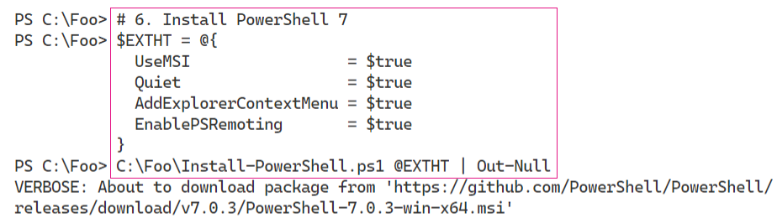

Insert image B42024_01_02.png

PowerShell 7 is a work in progress. Every day, the PowerShell team builds updated versions of PowerShell and releases previews of the next major release. The preview builds are mostly stable and allow you to try out new features that are coming in the next major release. The daily build allows you to view progress on a specific bug or feature. You may find it useful to install both of these (and ensure you keep them up to date as time goes by).

In step 7, you install the daily build and the latest Preview build, which looks like this:

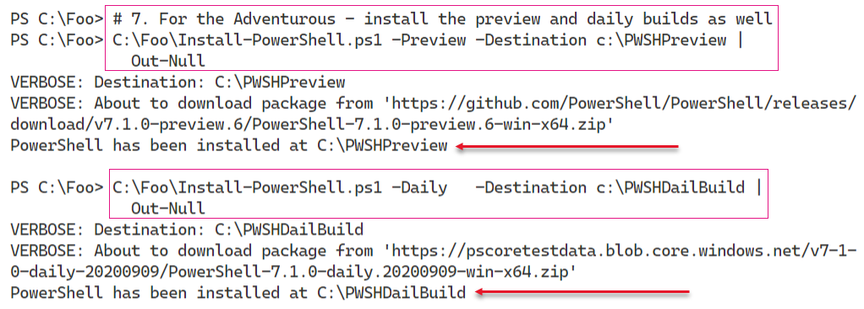

Insert image B42024_01_03.png

PowerShell uses Profile files to enable you to configure PowerShell each time you run PowerShell (whether in the PowerShell console or as part of VS Code or the ISE). In step 8, you download a sample PowerShell profile script and save it locally. Note that the profile file you create in step 8 is for Windows PowerShell only.

The Executable name for PowerShell 8 is pwsh.exe. In step 9, you view the versions of this file as follows:

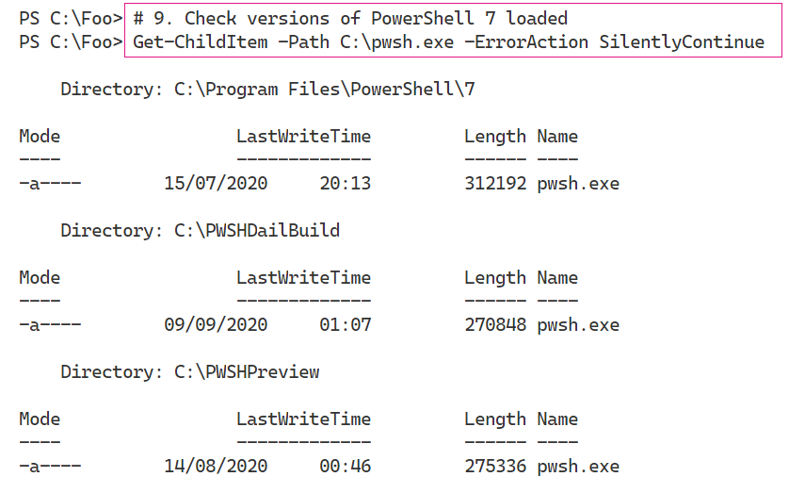

Insert image B42024_01_04.png

As you can see, there are 3 versions of PowerShell 7 installed on SRV1: the latest full release, the latest preview, and the build of the day.

## There's more...

In step 4, you use a shortened URL to download the Install-PowerShell.ps1 script. When you use Invoke-RestMethod, PowerShell discovers the underlying target URL for the script. The short URL allows Microsoft and the PowerShell team to publish a well-known URL and then have the flexibility to move the target location should that be necessary. The target URL, at the time of writing, is https://raw.githubusercontent.com/PowerShell/PowerShell/master/tools/install-powershell.ps1.

In step 7, you install both the latest daily build and the latest preview versions. The specific file versions you see are going to be different from the output shown here as at least for the preview versions!

# Using PWSH.EXE

With PowerShell 7, the name of the PowerShell executable is now pwsh.exe, as you saw in the previous recipe. After installing PowerShell 7 in Windows, you can start the PowerShell 7 console by clicking start and typing pwsh.exe, then hitting return. The PowerShell MSI installer does not create a start panel or taskbar shortcut.

## Getting Ready

You run this recipe on SRV1 after you have installed PowerShell 7.

## How to do it...

1. Run the PowerShell 7 console.

From the Windows desktop in SRV1, click on the Windows key, then type pwsh, followed by the enter key.

1. View the PowerShell Version

$PSVersionTable

1. View the $Host variable

$Host

1. Look at the PowerShell process

Get-Process -Id $Pid |

  Format-Custom MainModule -Depth 1

1. Look at resource usage statistics

Get-Process -Id $Pid |

  Format-List CPU,*Memory*

1. Update PowerShell Help

$Before = Get-Help -Name about_*

Update-Help -Force | Out-Null

$After = Get-Help -Name about_*

$Delta = $After.Count - $Before.Count

"{0} Conceptual Help Files Added" -f $Delta

1. How many commands are available?

Get-Command |

  Group-Object -Property CommandType

## How it works...

In step 1, you start the PowerShell 7 console on SRV1. The console should look like this:

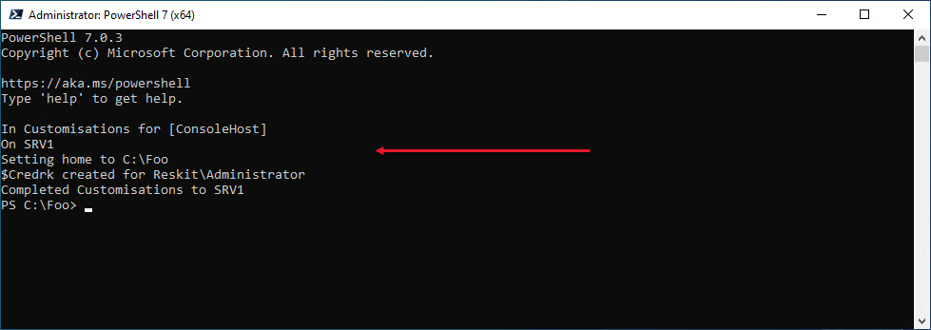

Insert image B42024_01_05.png

1. In step 2, you view the specific version of PowerShell by viewing the built-in variable $PSVersionTable, which looks like this:

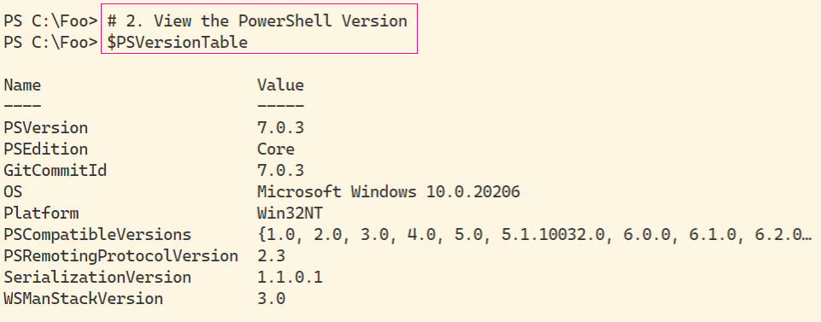

Insert image B42024_01_06.png

In step 3, you examine the $Host variable to determine details about the PowerShell 7 host (the PowerShell console), which looks like this:

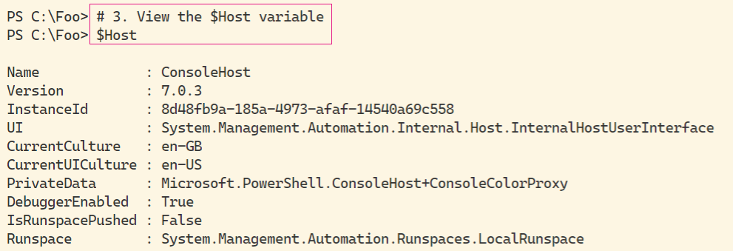

Insert image B42024_01_07.png

As you can see, in this case, you can see, the current culture is EN-GB. You may see a different value depending on which specific version of Windows Server you are using.

In step 4, you use Get-Process to look at the details of the PowerShell process, which looks like this:

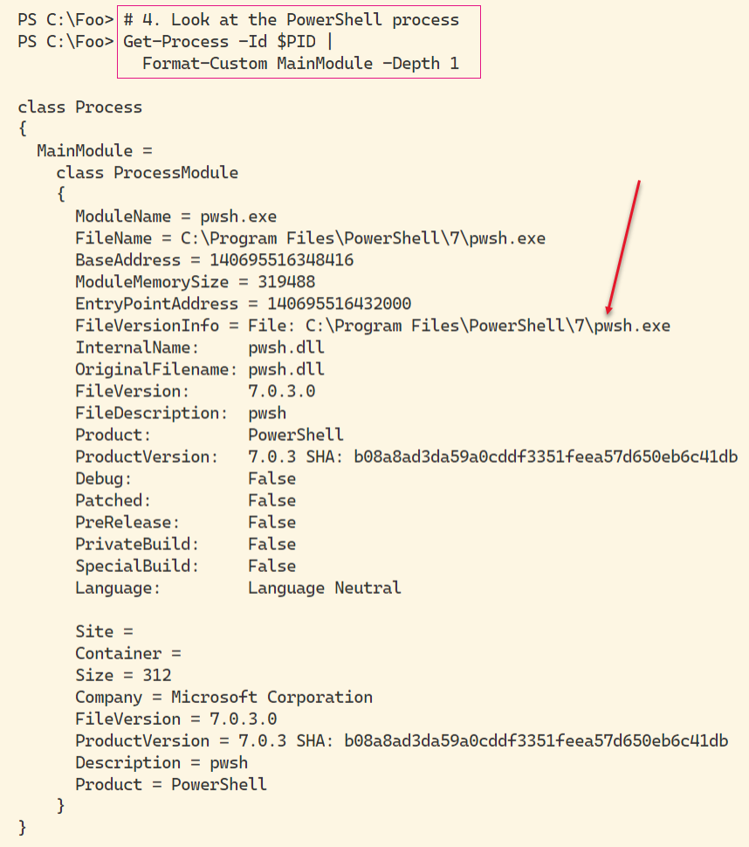

Insert image B42024_01_08.png

In this figure, you can see the path to the PowerShell 7 executable. This value changes if you are running the release version or the daily/preview releases.

You can see, in step 5, details of resource usage of the pwsh.exe process running on the SRV1 host.

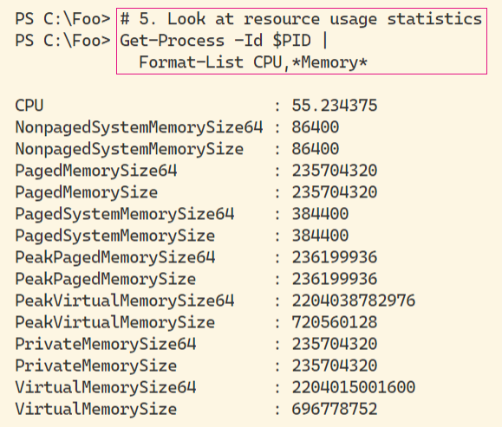

Insert image B42024_01_09.png

The values of each of the performance counters are likely to. You may see different values.

By default, Powershell 7, like Windows PowerShell, ships with minimum help files. You can, as you can see in step 6, use the Update-Help command to download updated PowerShell help content, like this:

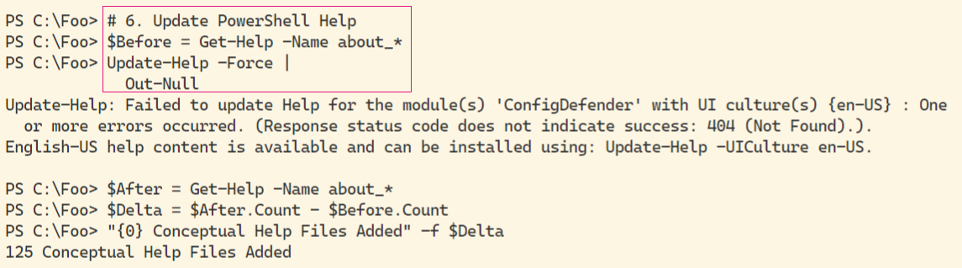

Insert image B42024_01_10.png

As you can see from the output, not all help files were updated. In this case, the ConfigDefender module does not, at present, have updated help information. Also note that although the UK English versions of help details may be missing, there are US English versions that you can install which may be useful.

Commands in PowerShell, include functions, cmdlets, and aliases. In step 7, you examine how many of each time of command is available by default, like this:

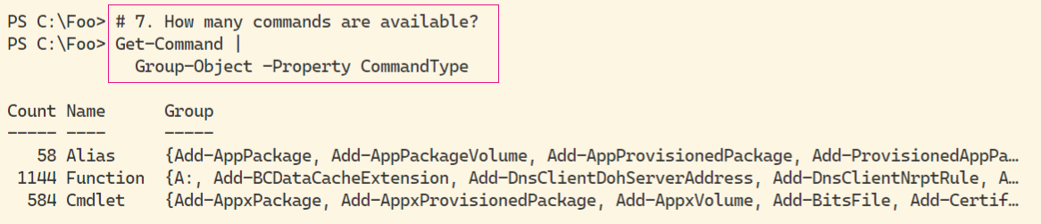

Insert image B42024_01_11.png

## There's more...

In step 1, you open the PowerShell console for the version of PowerShell you installed in “Installing PowerShell 7”. At the release of PowerShell 7.1, the version number you would see is 7.1.0. By the time you read this book, that version number may have advanced. To ensure you have the latest released version of PowerShell 7, re-run the Install-PowerShell.ps1 script you downloaded in “Installing PowerShell 7” In this step, you can also see the output generated by the Write-Host statements in the profile file you set up in “Introducing PowerShell 7”.

In step 4, you use the variable $PID, which contains the Windows process identifier of the PowerShell 7 console process. The actual value of $PID changes each time you run PowerShell, but the value always contains the process id of the current console process.

In step 7, you saw that you had 1786 commands available. This number changes as you add more features (and their accompanying modules) or download and install modules from repositories such as the PowerShell Gallery.

# Exploring PowerShell 7 Installation Artifacts

In PowerShell 7, certain objects added by the PowerShell 7 installer (and PowerShell 7) differ from those used by Windows PowerShell.

## Getting Ready

This recipe uses SRV1 after you have installed PowerShell 7. In this recipe, you use the PowerShell 7 console to run the steps.

## How to do it...

1. Check the version table for PowerShell 7 console

$PSVersionTable

1. Examine the PowerShell 7 installation folder

Get-Childitem -Path $env:ProgramFiles\PowerShell\7 -Recurse |

  Measure-Object -Property Length -Sum

1. Look at PowerShell Configuration JSON file

Get-ChildItem -Path $env:ProgramFiles\PowerShell\7\powershell*.json |

  Get-Content

1. Check Execution Policy for PowerShell 7

Get-ExecutionPolicy

1. View Module folders

$I = 0

$ModPath = $env:PSModulePath -split ';'

$ModPath |

  Foreach-Object {

    "[{0:N0}]   {1}" -f $I++, $_}

1. View the Modules

$TotalCommands = 0

$TotalModules  = 0

Foreach ($Path in $ModPath){

  Try { $Modules = Get-ChildItem -Path $Path -Directory -ErroraCtion Stop

        "Checking Module Path:  [$Path]"

  }

  Catch [System.Management.Automation.ItemNotFoundException] {

    "Module path [$path] DOES NOT EXIST ON $(hostname)"

  }

  Foreach ($Module in $Modules) {

    # "Module [$($module.name)] - Commands: [$($Cmds.Count)]"

    $TotalCommands += $Cmds.Count

    $TotalModules ++

  }

  ""

}

1. View totals of command and modules

"{0} commands in {1} modules" -f $TotalCommands, $TotalModules

## How it works...

In step 1, you examine the $PSVersionTable variable to view the version information for PowerShell 7, which looks like this:

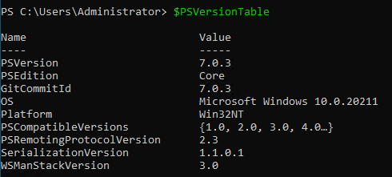

Insert image B42024_01_12.png

The PowerShell 7 installation program installs PowerShell 7 into a different folder (by default) from that used by Windows PowerShell. In step 2, you see a summary of the files installed into the PowerShell 7 installation folder as follows:

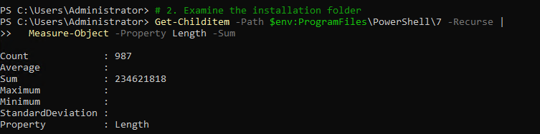

Insert image B42024_01_13.png

PowerShell 7 stores configuration values in a JSON file in the PowerShell 7 installation folder. In step 3, you view the contents of this file:

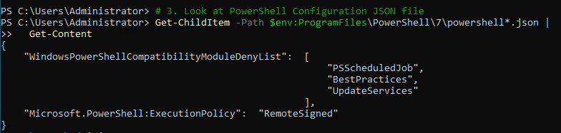

Insert image B42024_01_14.png

In step 4, you view the execution policy for PowerShell 7, as follows:



Insert image B42024_01_15.png

As with Windows PowerShell, PowerShell 7 loads commands from modules. PowerShell uses the $PSModulePath to determine which file store folders PowerShell 7 should use to find these modules. Viewing the contents of this variable, and discovering the folders, in step 5, looks like this:

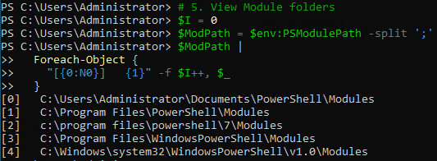

Insert image B42024_01_16.png

With those module folders defined (by default), you can check how many commands exist in each folder, in step 6, the output of which looks like this:

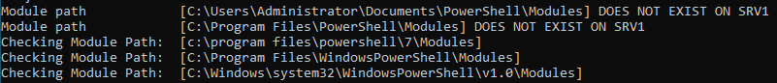

Insert image B42024_01_17.png

In step 7, you can view the results to see how many commands exist in each of the modules in each module path. The output looks like this:



Insert image B42024_01_18.png

## There's more...

In step 1, you viewed the PowerShell version table. Depending on when you read this book, the version numbers you see may be later than shown here.

In step 4, you viewed PowerShell 7’s execution policy. Each time PowerShell 7 starts up, it reads the JSON file to obtain the value of Execution policy. You can use Set-Execution policy to re-set the policy immediately, or change the value in the JSON file and restart the PowerShell 7 console.

In step 5, you viewed the default folders which PowerShell 7 uses to search for a module (by default). The first folder is your personal modules, followed by PowerShell 7 and then Windows PowerShell modules. We cover the Windows PowerShell modules and Windows PowerShell compatibility in more detail in Chapter 2.

# Building PowerShell 7 Profile Files

In Windows PowerShell and PowerShell 7, profile files contain code which PowerShell runs each time you start a new PowerShell console or a new instance of the ISE (or VS Code). These files enable you to pre-configure a PowerShell 7. You can add variables, PowerShell PS drives, functions and more using Profiles. As part of this book, there are PowerShell (and VS Code) profile file samples which you can download from GitHub.

This recipe downloads and installs the profile files for the PowerShell 7 console.

## Getting Ready

You run this recipe on SRV1 after you have installed PowerShell 7.

## How to do it...

1. Discover the profile file names

$ProfileFiles = $Profile |  Get-Member -MemberType NoteProperty

$ProfileFiles | Format-Table -Property Name, Definition

1. Check for Existence of each PowerShell Profile Files

Foreach ($ProfileFile in $ProfileFiles){

  "Testing $($ProfileFile.Name)"

  $ProfilePath = $ProfileFile.Definition.split('=')[1]

  If (Test-Path $ProfilePath){

    "$($ProfileFile.Name) DOES EXIST"

    "At $ProfilePath"

  }

  Else {

    "$($ProfileFile.Name) DOES NOT EXIST"

  }

  ""

}

1. Create Current User Current Host Profile

$CUCHProfile = $profile.CurrentUserCurrentHost

'Current user, current host profile path: '

"   [$CUCHPROFILE]"

1. Create Current user/Current host profile

$URI = 'https://raw.githubusercontent.com/doctordns/PACKT-PS7/master/' +

       'scripts/goodies/Microsoft.PowerShell_Profile.ps1'

New-Item $CUCHProfile -Force -WarningAction SilentlyContinue |

   Out-Null

(Invoke-WebRequest -Uri $URI -UseBasicParsing).Content |

  Out-File -FilePath  $CUCHProfile

1. Existing from PowerShell 7 console

Exit-PSHostProcess

1. Restart the PowerShell 7 console and view the profile output at startup
2. Get-ChildItem -Path $Profile

## How it works...

In step *1*, you discover the names of each of the 4 profile files (for the PowerShell 7 console), then view their name and location (that is, the definition) which looks like this:

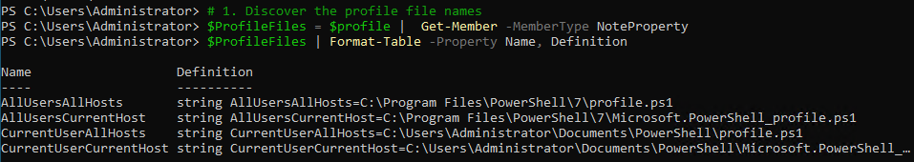

Insert image B42024_01_19.png

In step 2, you check to see which, if any, of the profile files exist, which looks like this:

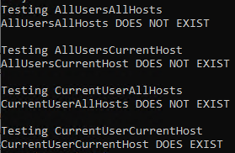

Insert image B42024_01_20.png

In step 3, you obtain and display the filename of the current user/current host profile file, which looks like this:



Insert image B42024_01_21.png

In step 4, you create an initial current user/current host profile file. This file is part of the GitHub repository which supports this book. In step 5, you exist the current PowerShell 7 console host. These two steps create no output.

In step 6, you start a new PowerShell profile. This time, as you can see here, the profile file exists, runs, and customizes the console:

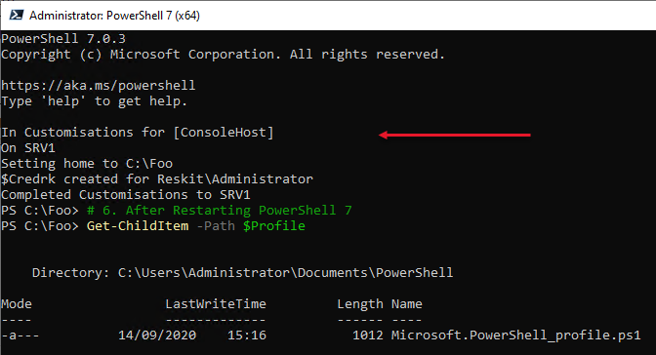

Insert image B42024_01_22.png

## There's more...

In step 4, you download a sample profile file. This file contains some customizations for the PowerShell console configuration, including changing the default starting folder (to C:\Foo), creating some aliases, PowerShell drives and a credential object. These represent sample content you might consider for including in your console profile file. Note that VIS Code, which you install in the next recipe, uses a separate current user/current host profile file which means you can customize PowerShell at the console and in VS code differently.

# Installing VS Code

The Windows PowerShell ISE was a great tool that Microsoft first introduced with Windows PowerShell v2 (and vastly improved with v3). This tool has reached feature completeness, and Microsoft has no plans for further development.

In its place, however, is Visual Studio Code, or VS Code. This open-source tool provides an extensive range of features for IT pros and others. For IT Pros, this should be your editor of choice. Whilst there is a learning curve (as for any new product), VS Code contains all the features you found in the ISE and more.

VS Code, and the available extensions, are works in progress. Each new release brings additional features which can be highly valuable. A recent addition, for example, is the ability to create diagrams directly in VS Code.

For more details on VS Code, see https://code.visualstudio.com/.

For details of VS Code extensions and the VS Code Extension Market Place, see https://code.visualstudio.com/docs/editor/extension-gallery#:~:text=You%20can%20browse%20and%20install,on%20the%20VS%20Code%20Marketplace.

## Getting Ready

You run this recipe on SRV1 after you have installed PowerShell 7 and have created a console profile file.

## How to do it...

1. Download the VS Code installation script from PS Gallery

$VSCPATH = 'C:\Foo'

Save-Script -Name Install-VSCode -Path $VSCPATH

Set-Location -Path $VSCPATH

1. Run the installation script and add in some popular extensions

$Extensions =  'Streetsidesoftware.code-spell-checker',

               'yzhang.markdown-all-in-one',

               'hediet.vscode-drawio'

$InstallHT = @{

  BuildEdition         = 'Stable-System'

  AdditionalExtensions = $Extensions

  LaunchWhenDone       = $true

}

.\Install-VSCode.ps1 @InstallHT

1. Exit VS Code
2. Restart VS Code by clicking on the Windows Key and typing code to bring up the VS Code tile in the Windows Start Panel. Then right-click the VS Code tile and select Run as Administrator to start VS Code as an administrator
3. Inside, VS Code, open a VS Code Terminal by typing Ctrl+Shift+’. From the terminal, type pwsh and return
4. Using VS Code, create a Sample Profile File for VS Code

$SAMPLE =

  'https://raw.githubusercontent.com/doctordns/PACKT-PS7/master/' +

  'scripts/goodies/Microsoft.VSCode_profile.ps1'

(Invoke-WebRequest -Uri $Sample).Content |

  Out-File $Profile

1. Update Local User settings for VS Code
2. $JSON = @'
3. {
4. "workbench.colorTheme": "PowerShell ISE",
5. "powershell.codeFormatting.useCorrectCasing": true,
6. "files.autoSave": "onWindowChange",
7. "files.defaultLanguage": "powershell",
8. "editor.fontFamily": "'Cascadia Code',Consolas,'Courier New'",
9. "workbench.editor.highlightModifiedTabs": true,
10. "window.zoomLevel": 1
11. }
12. '@
13. $JHT = ConvertFrom-Json -InputObject $JSON -AsHashtable
14. $PWSH = "C:\\Program Files\\PowerShell\\7\\pwsh.exe"
15. $JHT += @{
16. "terminal.integrated.shell.windows" = "$PWSH"
17. }
18. $Path = $Env:APPDATA
19. $CP   = '\Code\User\Settings.json'
20. $Settings = Join-Path  $Path -ChildPath $CP
21. $JHT |
22. ConvertTo-Json  |
23. Out-File -FilePath $Settings
24. Create a short cut to VS Code

$SourceFileLocation  = "$env:ProgramFiles\Microsoft VS Code\Code.exe"

$ShortcutLocation    = "C:\foo\vscode.lnk"

# Create a  new wscript.shell object

$WScriptShell        = New-Object -ComObject WScript.Shell

$Shortcut            = $WScriptShell.CreateShortcut($ShortcutLocation)

$Shortcut.TargetPath = $SourceFileLocation

#Save the Shortcut to the TargetPath

$Shortcut.Save()

1. Create a short cut to PowerShell 7

$SourceFileLocation  = "$env:ProgramFiles\PowerShell\7\pwsh.exe"

$ShortcutLocation    = 'C:\Foo\pwsh.lnk'

# Create a  new wscript.shell object

$WScriptShell        = New-Object -ComObject WScript.Shell

$Shortcut            = $WScriptShell.CreateShortcut($ShortcutLocation)

$Shortcut.TargetPath = $SourceFileLocation

#Save the Shortcut to the TargetPath

$Shortcut.Save()

1. Build Updated Layout XML

$XML = @'

<?xml version="1.0" encoding="utf-8"?>

<LayoutModificationTemplate

  xmlns="http://schemas.microsoft.com/Start/2014/LayoutModification"

  xmlns:defaultlayout=

    "http://schemas.microsoft.com/Start/2014/FullDefaultLayout"

  xmlns:start="http://schemas.microsoft.com/Start/2014/StartLayout"

  xmlns:taskbar="http://schemas.microsoft.com/Start/2014/TaskbarLayout"

  Version="1">

<CustomTaskbarLayoutCollection>

<defaultlayout:TaskbarLayout>

<taskbar:TaskbarPinList>

 <taskbar:DesktopApp DesktopApplicationLinkPath="C:\Foo\vscode.lnk" />

 <taskbar:DesktopApp DesktopApplicationLinkPath="C:\Foo\pwsh.lnk" />

</taskbar:TaskbarPinList>

</defaultlayout:TaskbarLayout>

</CustomTaskbarLayoutCollection>

</LayoutModificationTemplate>

'@

$XML | Out-File -FilePath C:\Foo\Layout.Xml

1. Import the start layout XML file

Import-StartLayout -LayoutPath C:\Foo\Layout.Xml -MountPath C:\

1. Create VSCode Profile for PowerShell 7

$CUCHProfile   = $profile.CurrentUserCurrentHost

$ProfileFolder = Split-Path -Path $CUCHProfile

$ProfileFile   = 'Microsoft.VSCode_profile.ps1'

$VSProfile     = Join-Path -Path $ProfileFolder -ChildPath $ProfileFile

$URI = 'https://raw.githubusercontent.com/doctordns/PACKT-PS7/master/' +

       "scripts/goodies/$ProfileFile"

New-Item $VSProfile -Force -WarningAction SilentlyContinue |

   Out-Null

(Invoke-WebRequest -Uri $URI -UseBasicParsing).Content |

  Out-File -FilePath  $VSProfile

1. Log off

logoff.exe

1. Log back into Windows and observe the taskbar
2. Run PowerShell console from the short cut
3. Run VS Code from the new taskbar shortcut and observe the profile file running

## How it works...

In step 1, you download the VS Code installation script from the PowerShell Gallery. This step produces no output.

Then, in step 2, you run the installation script and add in three specific extensions. Running this step in the PowerShell 7 console looks like this:

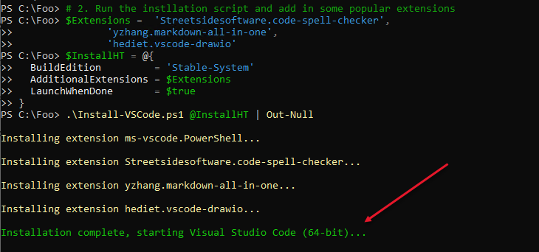

Insert image B42024_01_23.png

Once VS Studio has started, you can see the opening window, like this:

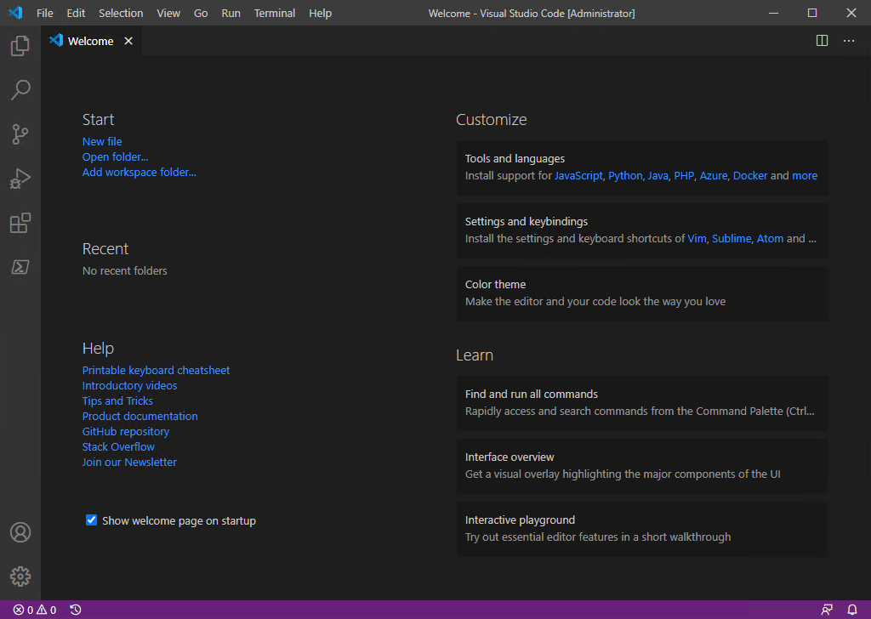

Insert image B42024_01_24.png

You then, in step 3, you close this window. You run VS Code as Administrator in step 4. In step 5, you open a new VS Code terminal and run PowerShell 7, which now looks like this:

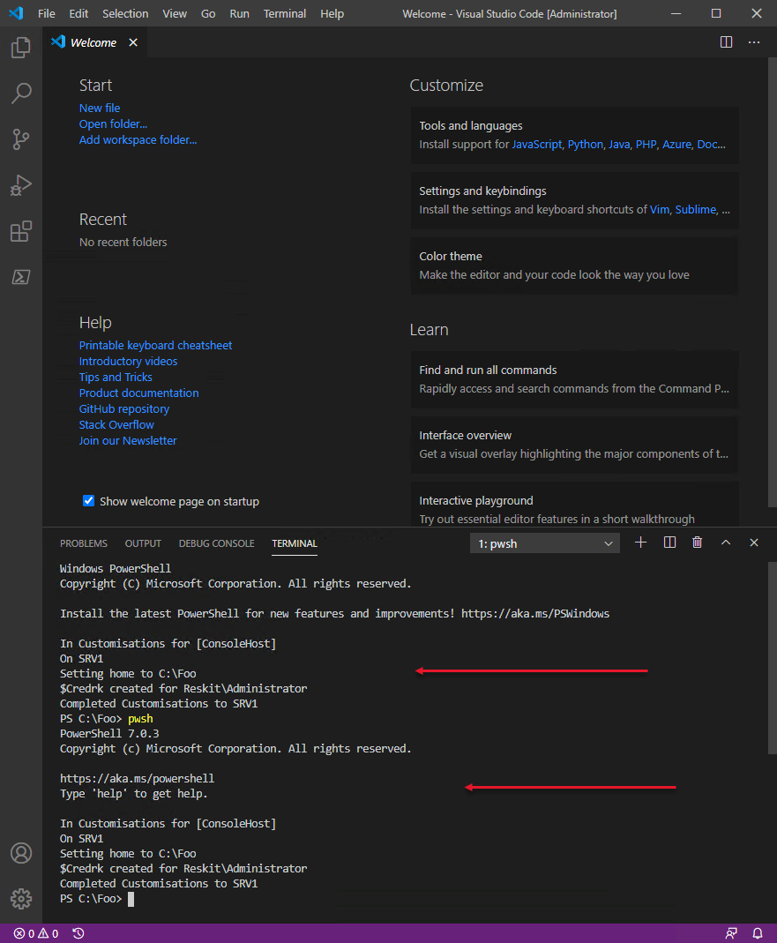

Insert image B42024_01_25.png

In step 6, you create a VS Code sample profile file. This step generates no output. In step 7, you update several VS Code runtime options. In step 8, you create a short cut to VS Code, and in step 9, you create a short cut to the PowerShell 7 console. In step 10, you update the XML that describes the Windows task pane to add the shortcuts to VS Code and the PowerShell console. In step 11, you import the updated task pane description back into Windows. In step 12, you create a VS Code profile for PowerShell 7. These steps produce no output as such.

Next, in step 13, you log off from Windows. In step 14, you re-login and note the updated taskbar, as you can see here:

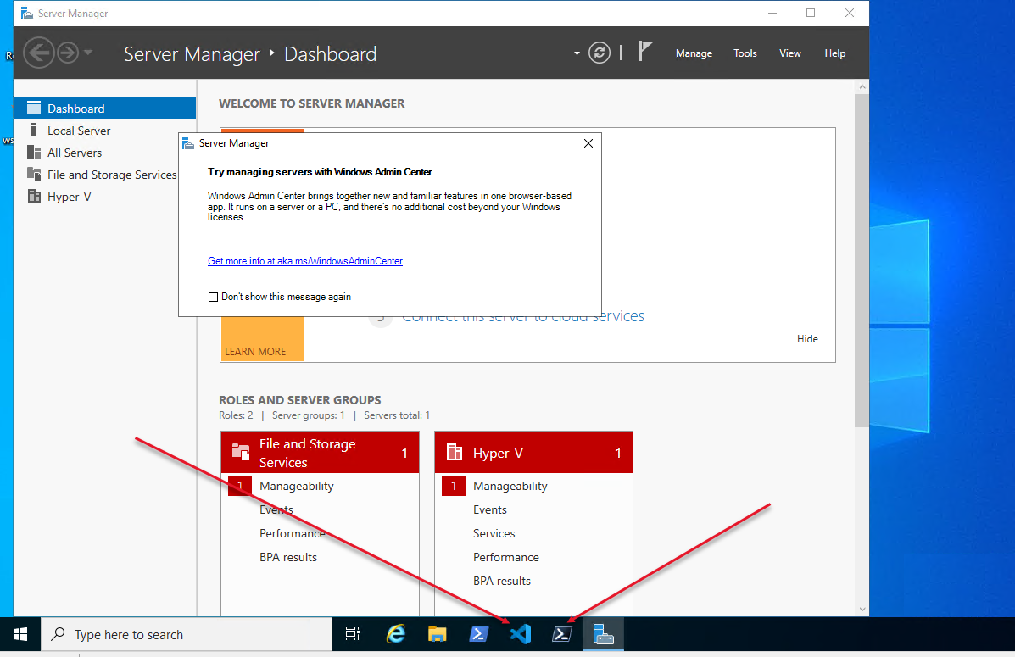

Insert image B42024_01_26.png

In step 15, you open a PowerShell 7 console which looks like this:

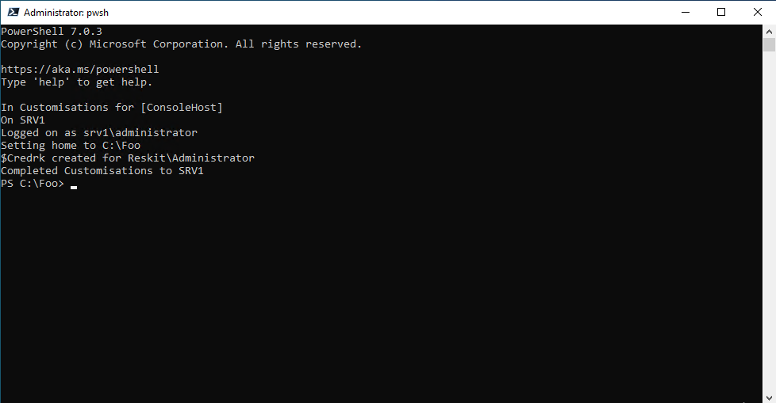

Insert image B42024_01_27.png

In step 16, you open VS Code, which looks like this:

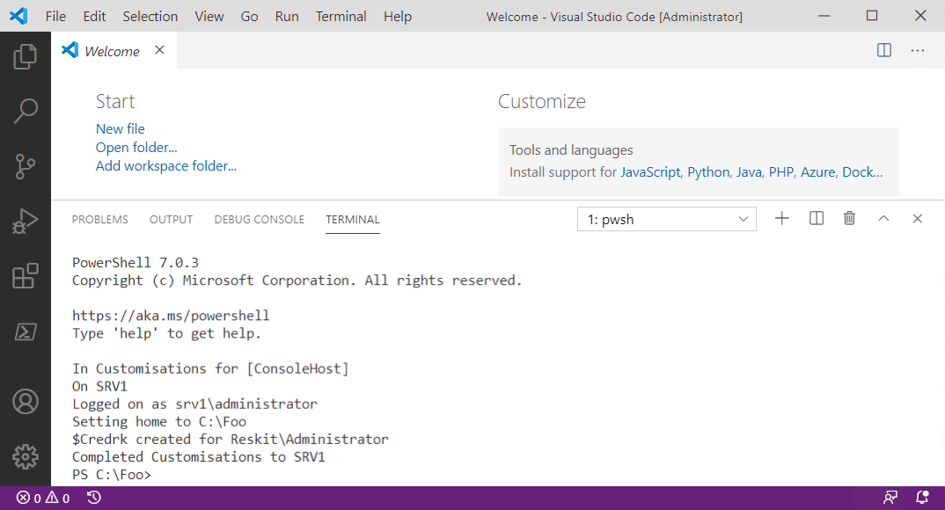

Insert image B42024_01_28.png

## There's more...

In step 2, you install vs Code and three additional VS Code extensions. The Streetsidesoftware.code-spell-checker extension provides spell-checking for your scripts and other files. The yzhang.markdown-all-in-one extension supports the use of Markdown. This extension is useful if, for example, you are writing documentation in Github or updating the existing public PowerShell 7 help information. The hediet.vscode-drawio extension enables you to create rich diagrams directly in VS Code. Visit the VS Code market place for details on these and other extensions.

In step 4, you ensure you are running VS Code as Administrator. Some of the code requires this and fails if you are not running PowerShell (inside VS Code) as an admin.

In step 5, you open a terminal inside VS Code. In VS Code the ‘terminal’ is initially a Windows PowerShell console. You can see in the output the results of running the Profile file for Windows PowerShell. This terminal is the one you see inside VS code by default.

In step 7, you update and save some updates to VS Code settings. Note that in this step, you tell VS Code where to find the version of PowerShell you wish to run. You can, should you choose, change this to run a preview version of PowerShell or even the daily build.

In step 8 and step 9, you create shortcuts to VS Code and the PowerShell 7 console. In step 110 and you update the layout of the Windows Task Bar to include the two short cuts. Unfortunately, you have to log off (as you do in step 13) before logging back into Windows where you can observe and use the two shortcuts.

# Installing Cascadia Code Font

As part of the launch of Visual Studio Code, Microsoft also created a new and free type font which you can download and use both at the PowerShell 7 console and inside VS Code. This recipe shows how you can download the font, install it, and set to be the default in VS Code.

## Getting Ready

You run this recipe on SRV1 after you have installed both PowerShell 7 and VS Code.

## How to do it...

1. Get Download locations for the Cascadia Code font

$CascadiaFont    = 'Cascadia.ttf'    # font file name

$CascadiaRelURL  = 'https://github.com/microsoft/cascadia-code/releases'

$CascadiaRelease = Invoke-WebRequest -Uri $CascadiaRelURL # Get all of them

$CascadiaPath    = "https://github.com" + ($CascadiaRelease.Links.href |

                      Where-Object { $_ -match "($CascadiaFont)" } |

                        Select-Object -First 1)

$CascadiaFile   = "C:\Foo\$CascadiaFont"

1. Download Cascadia Code font file

Invoke-WebRequest -Uri $CascadiaPath -OutFile $CascadiaFile

1. Install Cascadia Code font

$FontShellApp = New-Object -Com Shell.Application

$FontShellNamespace = $FontShellApp.Namespace(0x14)

$FontShellNamespace.CopyHere($CascadiaFile, 0x10)

1. Restart VS Code by clicking on the shortcut in the taskbar

## How it works...

In step 1, you discover the latest version of the Cascadia Code font, and in step 2, you download this font.

In step 3, you install the Font into Windows. Since Windows does not provide any cmdlets to perform the font installation, you rely on the older Windows Shell.Application COM object.

In step 4, you restart VS Code and note the new font which now looks like this:

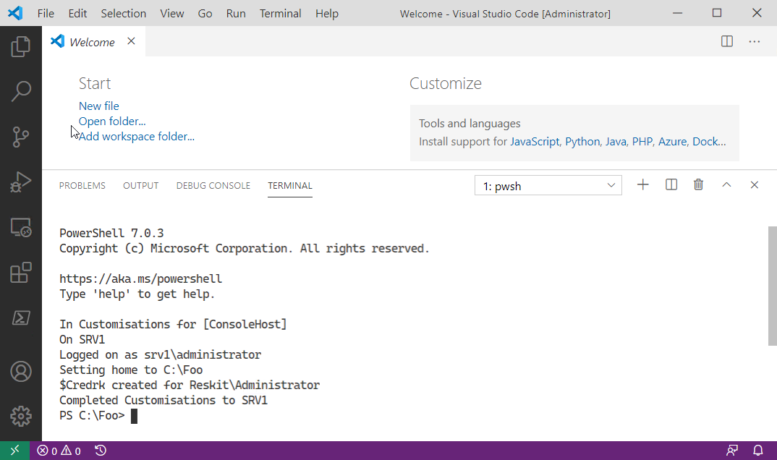

Insert image B42024_01_29.png

## There's more...

# Exploring PSReadLine

PSReadline is a PowerShell module that provides additional console editing features within both PowerShell 7 and Windows PowerShell. The module provides a command-line editing experience that is on a par with the best of the Linux command shells (e.g. BASH).

When you type into a PowerShell console, PSReadline intercepts your keystrokes to provide syntax coloring, simple syntax error notification, and a great deal more. PSReadline is highly customizable, enabling you to customize your environment. Some key features of PSReadline include:

* Syntax coloring of the command line entries
* Multi-line editing
* History Management
* Customizable key bindings
* Highly customizable

For an overview of PSReadLine, see https://docs.microsoft.com/powershell/module/psreadline/about/about_psreadline. And for more details, you can view the PSReadLine’s GitHub README file: https://github.com/PowerShell/PSReadLine/blob/master/README.md.

The PSReadline module ships natively with PowerShell 7. At startup in both the console and VS Code, PowerShell imports PSReadline so it is ready for you to use. You can also use PSReadline in Windows PowerShell.

The PSReadline module is a work in progress. Microsoft incorporated an early version of this module within Windows PowerShell V3. Windows PowerShell 5.1 (and the ISE) inside Windows Server ships with PSReadLine V2. If you are still using earlier versions of Windows PowerShell, you can download and utilize the latest version of PSReadLine.

The module has improved and, with the module’s V2 release, some changes were made that are not backwards compatible. Many blog articles, for example, use the older syntax for Set-PSReadLineOption and fail with version 2 (and later) of the module. Likewise, some of the examples in this recipe fail should you run them utilizing PSReadline V1.

## Getting Ready

This recipe uses SRV1 after you have installed PowerShell 7, VS Code, and the Cascadia Code font (and customized your environment).

## How to do it...

1. Get Commands in the PSReadline module

Get-Command -Module PSReadLine

1. Get the first 10 PSReadine key handlers

Get-PSReadLineKeyHandler |

  Select-Object -First 10

    Sort-Object -Property Key |

      Format-Table -Property Key, Function, Description

1. Discover a count of unbound key handlers

$Unbound = (Get-PSReadLineKeyHandler -Unbound).count

"$Unbound unbound key handlers"

1. Get the PSReadline options

Get-PSReadLineOption

1. Determine VS Code theme name

$Path       = $Env:APPDATA

$CP         = '\Code\User\Settings.json'

$JsonConfig = Join-Path  $Path -ChildPath $CP

$ConfigJSON = Get-Content $JsonConfig

$Theme = $ConfigJson |

           ConvertFrom-Json |

Select-Objet -ExpandProperty 'workbench.colorTheme'

1. If the theme name is  Visual Studio Light, change the color scheme

If ($Theme -eq 'Visual Studio Light') {

  Set-PSReadLineOption -Colors @{

    Member    = "`e[33m"

    Number    = "`e[34m"

    Parameter = "`e[35m"

    Command   = "`e[34m"

  }

}

## How it works...

In step 1, you view the commands in the PSReadline Module, which looks like this:

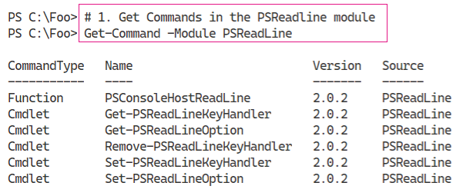

Insert image B42024_01_30.png

In step 2, you display the first ten PSReadline key handlers currently in use, which looks like this:

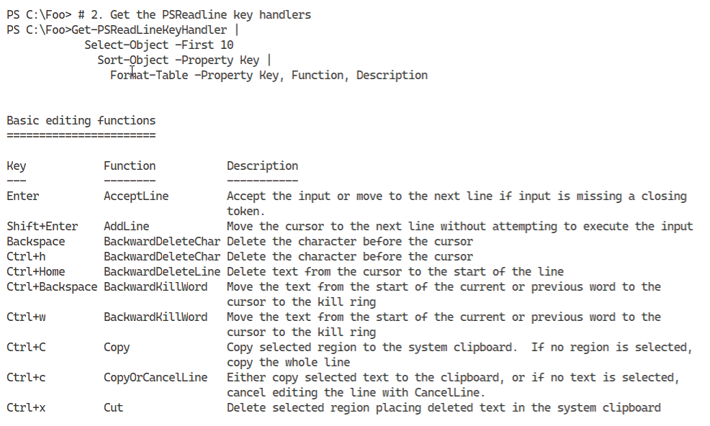

Insert image B42024_01_31.png

PSReadline provides over 160 internal functions to which you can bind a key combination. In step 3, you discover how many functions are unbound currently, which looks like this:

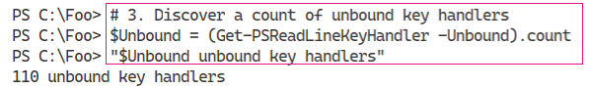

Insert image B42024_01_32.png

In step 4, you view the PSReadline options as you can see here:

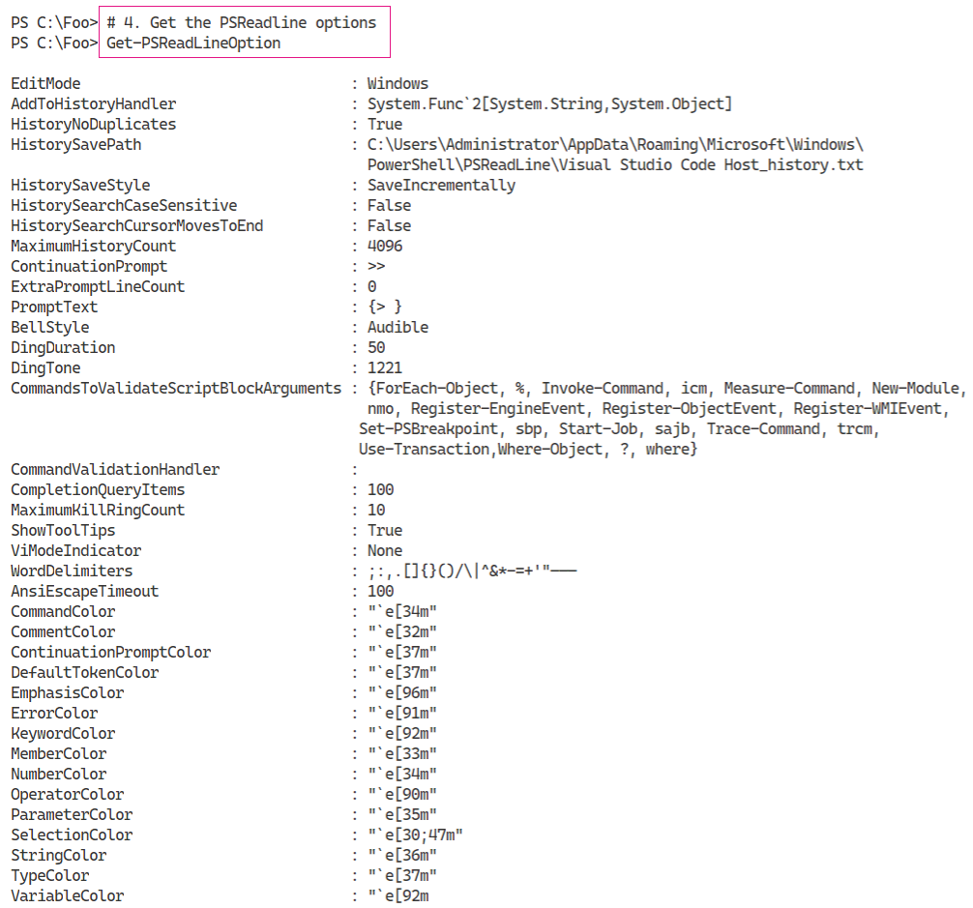

Insert image B42024_01_33.png

In step 5, and step 6, you determine the current VS Code theme name and update the colors used by PSReadline for better clarity. These two steps produce no output, although you should see the colours of specific PowerShell syntax tokens change (run Get-PSReadLineOption to see the changes).

## There's more...

In step 1, you view the commands inside the PSReadline module. The PSConsoleHostReadLine function is the entry point to this module’s functionality. When the PowerShell console starts, it loads this module and invokes the PSConsoleHostReadLine function.

One small downside to PSReadline is that it does not work well with all Windows screen reader programs. For accessibility reasons, if the PowerShell console detects you are using any screen reader program, the console startup process does not load PSReadline. You can always load PSReadLine manually either in the console or by updating your startup profile(s).

In step 2, you view the key handlers currently use by PSReadline. Each key handler maps a keystroke combination (for example, Ctrl+L) to one of over 160 internal PSReadline functions. By default, Ctrl+L maps to PSReadline’s ClearScreen function - when you type that sequence, PSReadline clears the screen in the console.

In step 5 and step 6, you detect the VS Code theme name and adjust the colour scheme to match your preferences. To some degree, PSReadline and VSCode’s colour themes can result in hard to read colour combinations. If that is the case, persist the specific settings into your VS Code profile file.

# Installing PowerShell 7 in Windows Subsystem for Linux

PowerShell 7 is cross-platform, and you can use PowerShell on Windows, macOS and most distributions of Linux. It is a feature of Linux that the installations of applications such as PowerShell differ. The tools you use, for example in Ubuntu, are different from those you use in other distributions.

With the latest versions of Windows and Windows Server, Microsoft has implemented the Windows Subsystem for Linux (WSL). WSL allows you to run a (supported) Linux distribution inside Windows. For a more in-depth look at WSL, see https://docs.microsoft.com/en-us/windows/wsl/about.

## Getting Ready

This recipe uses SRV1 after you have installed PowerShell 7 and VS Code.

## How to do it...

1. Step by step with code:

## How it works...

To be added

## There's more...

To be added